|  |  |
| --- | --- |
| Date | 04/11/2022 |
| Team ID | PNT2022TMID53565 |
| Project Title | Statistical Machine Learning Approaches to Liver Disease Prediction |
| Maximum Marks | 4 |

**Project Design Phase-II**

**Data Flow Diagram &User Stories**

**Data Flow Diagrams:** A Data Flow Diagram (DFD) is a traditional visual representation of the information flows within a system. A neat and clear DFD can depict the right amount of the system requirement graphically. It shows how data enters and leaves the system, what changes the information, and where data is stored.

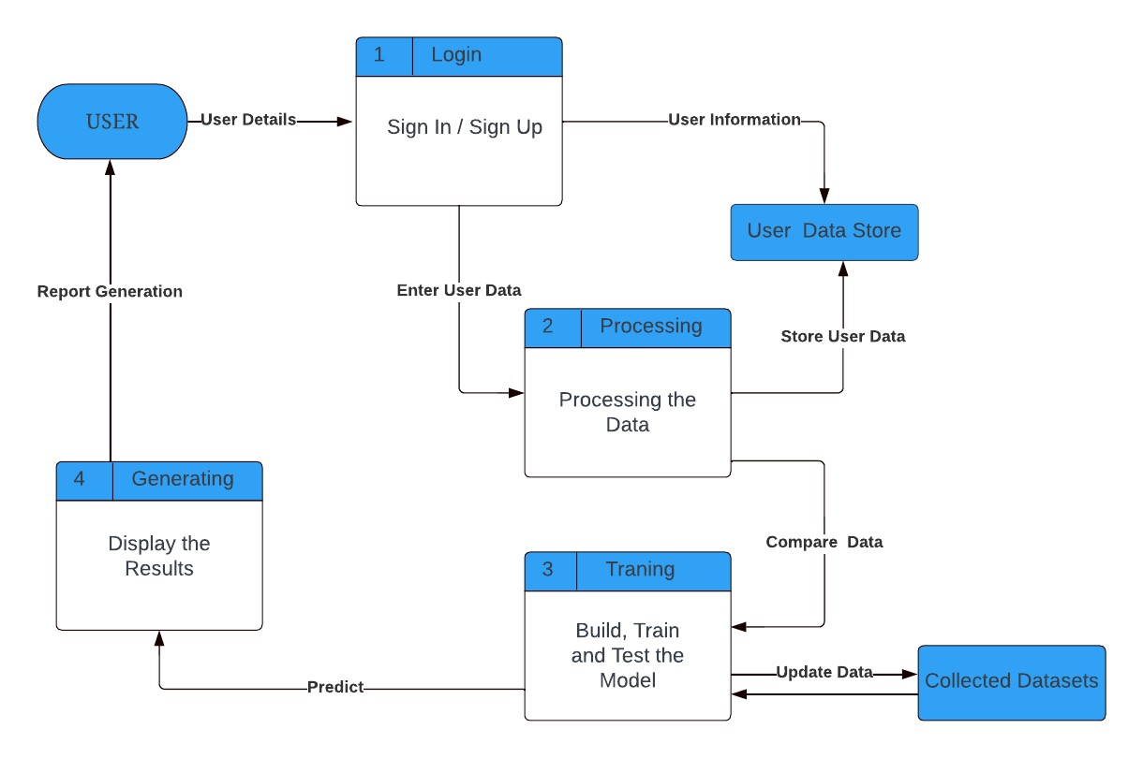

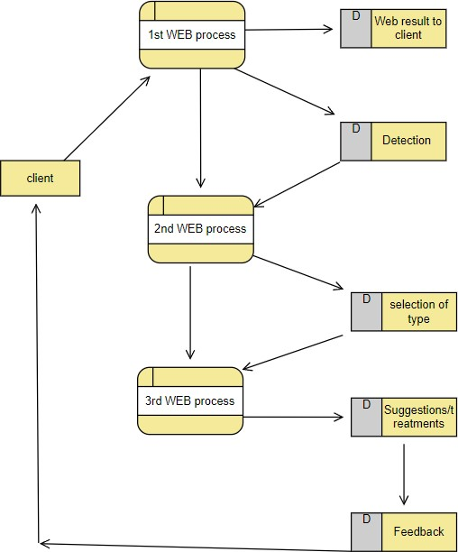

**User Stories**: Use the below template to list all the user stories for the product.

|  |  |  |  |  |  |  |
| --- | --- | --- | --- | --- | --- | --- |
| User Type | Functional Requirement (Epic) | User Story Number | User Story / Task | Acceptance criteria | Priority | Release |
| Customer (Mobile user) | Registration | USN-1 | As a user, I can register for the application by entering my email, password, and confirming my password. | I can access my account / dashboard | High | Sprint-1 |
|  |  | USN-2 | As a user, I will receive confirmation email once I have registered for the application | I can receive confirmation email & click confirm | High | Sprint-1 |
|  | Login | USN-3 | As a user, I can log into the application by entering email & password | I can access the dashboard | High | Sprint-1 |
|  | Dashboard | USN-4 | As a user, I must enter my details | I can retrieve information anywhere | Medium | Sprint-2 |
|  | Dashboard | USN-5 | As a user, I must enter my details | I can view various pages | High | Sprint-1 |
| Customer (Web user) | Upload Images | USN-6 | As a user, I can upload the image that required for finding whether liver disease is there are not. | Can get result based on the information provided. | Medium | Sprint-3 |
|  | Enter data | USN-7 | As a user, I can enter the required data from the scanned report. | Can get result based on the information provided | High | Sprint-3 |
|  | Report | USN-8 | As a user, I can generate the report in PDF format. | Result can be generated in PDF format in user login. | Low | Sprint-4 |
|  | Search | USN-9 | As a user, I can search for the specialist and best hospital in that respective field. | I can receive information on various doctors and hospitals. | Low | Sprint-4 |
| Administrator | Analyse | USN-10 | As an admin, I will analyse the given data | I can analyse the given data. | High | Sprint-2 |